**BÀI TẬP THỰC HÀNH 01  
MÔN HỌC SÂU (DEEP LEARNING)**

Họ và tên: **Hà Minh Đức**

Mã sinh viên: DTC1954802010077

Lớp: CNTT K18K

**Bài tập 01:**

# 1. Xây dựng chương trình thực hiện phép tích chập (Convolution) trong ảnh.

**Code:**

"""

Created on Wed Mar 1 16:15:13 2023

@author: Admin

"""

# 1. Xây dựng chương trình thực hiện phép tích chập (Convolution) trong ảnh.

import cv2

import numpy as np

image = cv2.imread('../img/img2.jpg')

# Print error message if image is null

if image is None:

print('Could not read image')

# scale

scale_percent = 60

w = int(image.shape[1] * scale_percent / 100)

h = int(image.shape[0] * scale_percent / 100)

dim = (w, h)

# resize image

image = cv2.resize(image, dim, interpolation = cv2.INTER_AREA)

# Apply identity kernel

kernel1 = np.array([[0, 0, 0],

[0, 1, 0],

[0, 0, 0]])

identity = cv2.filter2D(src=image, ddepth=-1, kernel=kernel1)

cv2.imshow('Original', image)

cv2.imshow('Identity', identity)

cv2.waitKey()

cv2.imwrite('../imgExported/identity.jpg', identity)

cv2.destroyAllWindows()

# Apply blurring kernel

kernel2 = np.ones((5, 5), np.float32) / 25

img = cv2.filter2D(src=image, ddepth=-1, kernel=kernel2)

cv2.imshow('Original', image)

cv2.imshow('Kernel Blur', img)

cv2.waitKey()

cv2.imwrite('../imgExported/blur_kernel.jpg', img)

cv2.destroyAllWindows()

# Laplacian

kernel3 = np.array((

[0, 1, 0],

[1, -4, 1],

[0, 1, 0]), dtype="int")

img = cv2.filter2D(src=image, ddepth=-1, kernel=kernel3)

cv2.imshow('Original', image)

cv2.imshow('Kernel Laplacian', img)

cv2.waitKey()

cv2.imwrite('../imgExported/Laplacian.jpg', img)

cv2.destroyAllWindows()

# Sharpen

kernel4 = np.array((

[0, -1, 0],

[-1, 5, -1],

[0, -1, 0]), dtype="int")

img = cv2.filter2D(src=image, ddepth=-1, kernel=kernel4)

cv2.imshow('Original', image)

cv2.imshow('Sharpen Laplacian', img)

cv2.waitKey()

cv2.imwrite('../imgExported/Sharpen.jpg', img)

cv2.destroyAllWindows()

**Kết quả:**



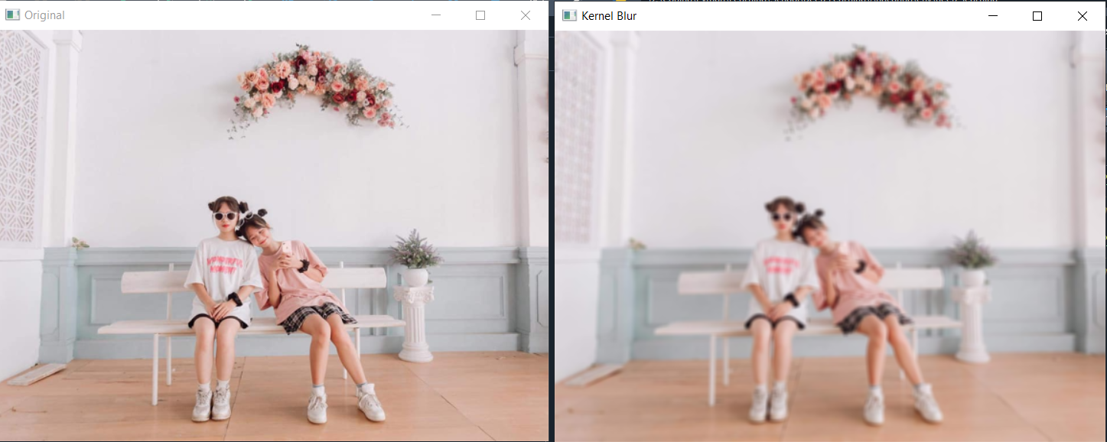

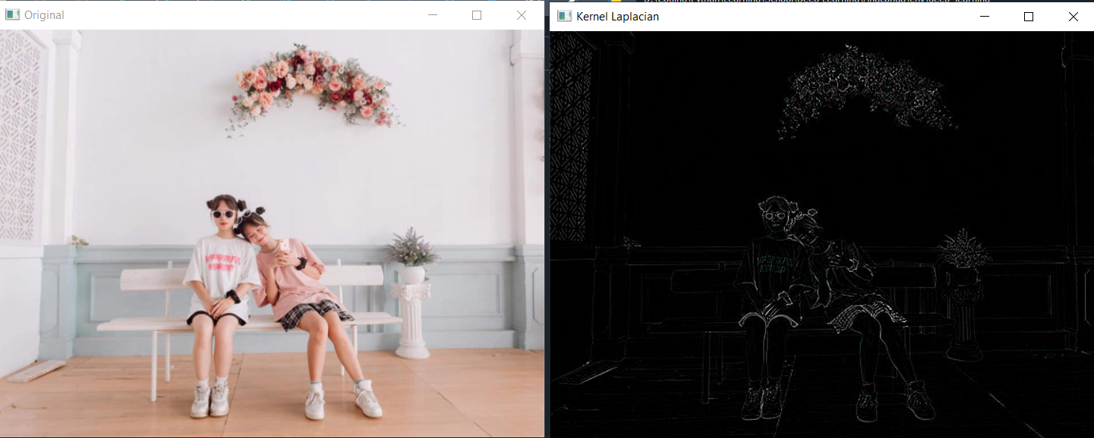

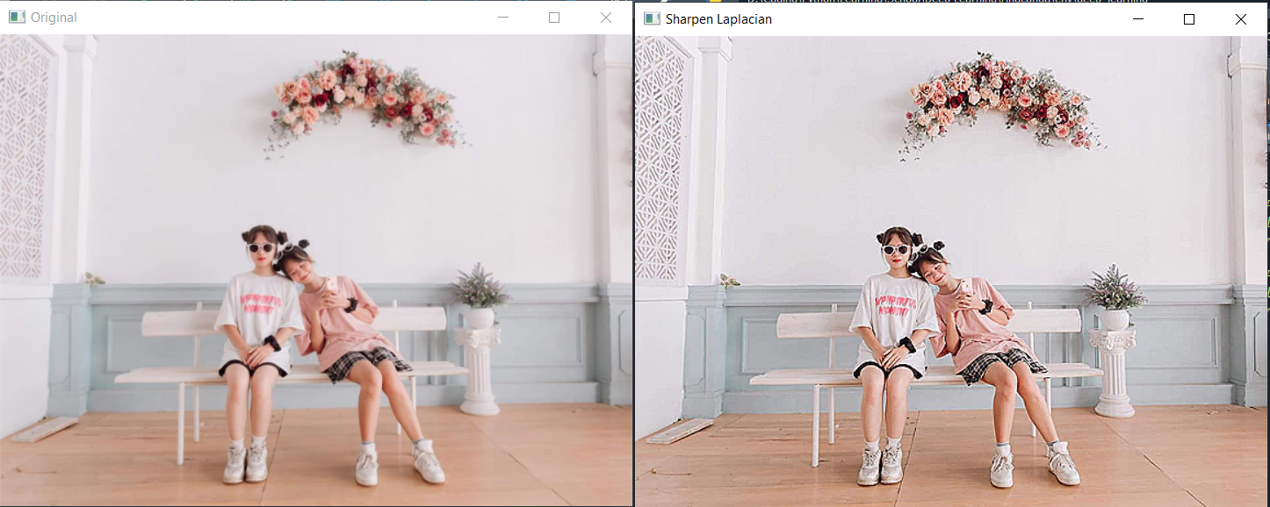

**Bài tập 02:**

# 2. Xây dựng chương trình thực hiện đệm (Padding) trong ảnh.

**Code:**

# -*- coding: utf-8 -*-

"""

Created on Wed Mar 1 16:40:04 2023

@author: Admin

"""

# 2. Xây dựng chương trình thực hiện đệm (Padding) trong ảnh.

import cv2

import numpy as np

image = cv2.imread('../img/img2.jpg')

# Print error message if image is null

if image is None:

print('Could not read image')

# scale

scale_percent = 60

w = int(image.shape[1] * scale_percent / 100)

h = int(image.shape[0] * scale_percent / 100)

dim = (w, h)

# resize image

image = cv2.resize(image, dim, interpolation = cv2.INTER_AREA)

# using copyMakeBorder(src, top, bottom, left, right, borderType = cv2.BORDER_CONSTANT, cv2.BORDER_REFLECT, value = rgb())

imageHasBorder = cv2.copyMakeBorder(image, 10, 10, 10, 10, cv2.BORDER_CONSTANT, None, value = (0, 255, 255))

cv2.imshow('Original', image)

cv2.imshow('image has border', imageHasBorder)

cv2.waitKey()

cv2.imwrite('../imgExported/imageHasBorder.jpg', imageHasBorder)

cv2.destroyAllWindows()

# using copyMakeBorder - BORDER_CONSTANT

imageHasBorderRef = cv2.copyMakeBorder(image, 100, 100, 50, 50, cv2.BORDER_REFLECT)

cv2.imshow('Original', image)

cv2.imshow('image has border reflect', imageHasBorderRef)

cv2.waitKey()

cv2.imwrite('../imgExported/imageHasBorder.jpg', imageHasBorderRef)

cv2.destroyAllWindows()

**Kết quả:**

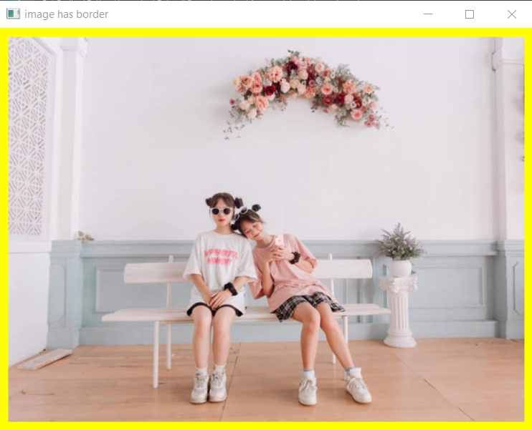

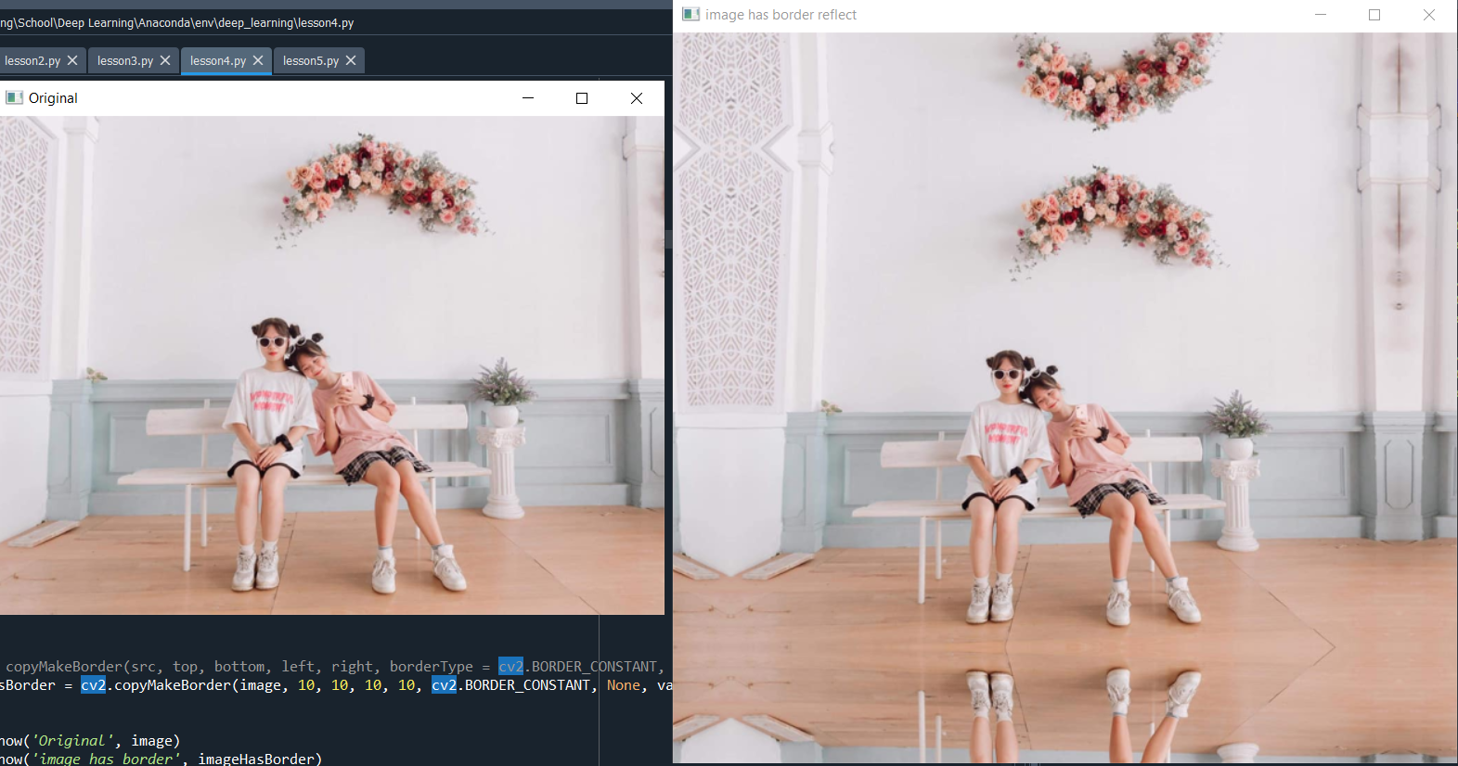

**Bài tập 03:**

# 3. Xây dựng chương trình thực hiện sải bước (Stride) trong ảnh.

**Code:**

# -*- coding: utf-8 -*-

"""

Created on Wed Mar 1 16:54:49 2023

@author: Admin

"""

# 3. Xây dựng chương trình thực hiện sải bước (Stride) trong ảnh.

import cv2

import numpy as np

# func

def apply_sliding_window(img, kernel, padding=0, stride=1):

h, w = img.shape[:2]

img_p = np.zeros([h+2*padding, w+2*padding])

img_p[padding:padding+h, padding:padding+w] = img

kernel = np.array(kernel)

assert len(kernel.shape) == 2 and kernel.shape[0] == kernel.shape[1] # square kernel

assert kernel.shape[0] % 2 != 0 # kernel size is odd number

k_size = kernel.shape[0]

k_half = int(k_size/2)

y_pos = [v for idx, v in enumerate(list(range(k_half, h-k_half))) if idx % stride == 0]

x_pos = [v for idx, v in enumerate(list(range(k_half, w-k_half))) if idx % stride == 0]

new_img = np.zeros([len(y_pos), len(x_pos)])

for new_y, y in enumerate(y_pos):

for new_x, x in enumerate(x_pos):

if k_half == 0:

pixel_val = img_p[y, x] * kernel # element-wise multiply

else:

pixel_val = np.sum(img_p[y-k_half:y-k_half+k_size, x-k_half:x-k_half+k_size] * kernel) # dot product: https://minhng.info/toan-hoc/y-nghia-tich-vo-huong.html

new_img[new_y, new_x] = pixel_val

return new_img

def apply_sliding_window_on_3_channels(img, kernel, padding=0, stride=1):

layer_blue = apply_sliding_window(img[:,:,0], kernel, padding, stride)

layer_green = apply_sliding_window(img[:,:,1], kernel, padding, stride)

layer_red = apply_sliding_window(img[:,:,2], kernel, padding, stride)

new_img = np.zeros(list(layer_blue.shape) + [3])

new_img[:,:,0], new_img[:,:,1], new_img[:,:,2] = layer_blue, layer_green, layer_red

return new_img

# import image

image = cv2.imread('../img/img2.jpg')

# Print error message if image is null

if image is None:

print('Could not read image')

new_img = apply_sliding_window_on_3_channels(image, kernel=[[1]], padding=0, stride=2)

cv2.imwrite('../imgExported/imgNew.jpg', new_img)

lighten_blur_img = apply_sliding_window_on_3_channels(image, kernel=[[0.33, 0.33, 0.33], [0.33, 0.33, 0.33], [0.33, 0.33, 0.33]], padding=1, stride=1)

cv2.imwrite('../imgExported/imagelightenBlur.jpg', lighten_blur_img)

print('Success!')

cv2.waitKey()

**Kết quả:**



imagelightenBlur

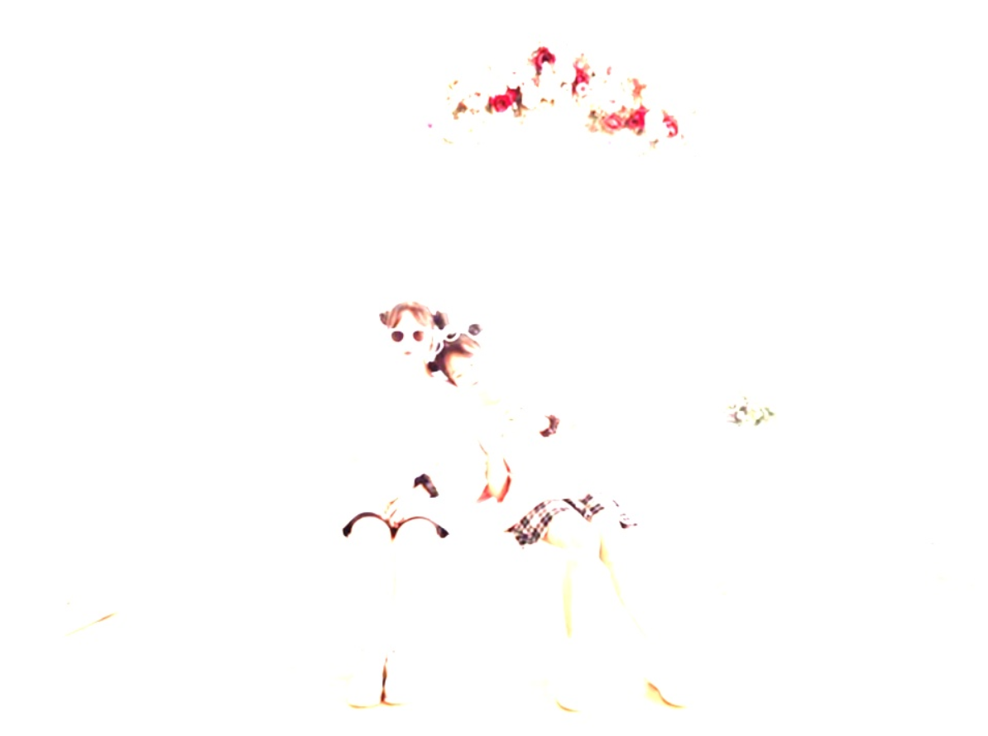

**Bài tập 04:**

4. Xây dựng chương trình thực hiện gộp (Pooling) trong ảnh

**Code:**

.

…